Title
Sub Title
First Author¹Second Auther1¹Third Auther2²
Affiliation 1¹
Affiliation 2²

Abstract: Abstracts should be written in 10 points of Times New Roman Font, and should not exceed 150 words. Do not insert any figures or tables in abstract.
Keywords: No more than 5 keywords should be written here.

抄録： Abstract in Japanese should be written here in 10 point of MS-Mincho Font, and should not exceed 400 characters.
キーワード: No more than 5 keywords should be written in Japanese here.
--------------------------------------------------------------------------------

1. Introduction
1 Fonts
The title should be in 14 points (bold) of Times New Roman and the bub title should be in 12 points of Times New Roman and in bold. Authors' names and affiliations should be in 12 points of Times New Roman. Please carry out these lines centered.
Please describe the text in two columns, 10.5 point Times New Roman.
2 Figures and tables
When you want to insert tables or figures, please use monochrome printing and stick on the appropriate position in a text. Also, please make the number of a figure and a table into Arabic figures (e.g. Fig. 1, Table 1), and number should be in ascending order from 1, respectively. Please put the caption of a figure under a figure and write the caption of a table before a table. In addition, please be careful to make characters in a table or a figure as readable size.

Table.1 Table caption
 | A | B | C
System 1 | 10.5 | 12.9 | 21.5
System 2 | 13.7 | 11.3 | 19.5

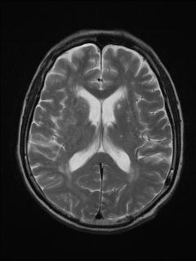
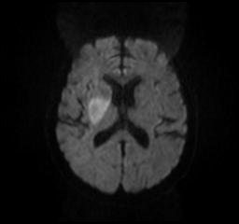
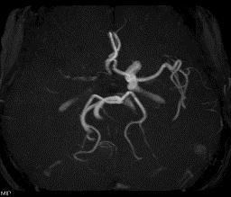

Fig.1 Figure Caption

A: Diffusion-weighted Imaging, B: MRA, C: T2-weighted Imaging

3 Page Settings
The space of each page should be given upper as 35mm, right, left, and the bottom as 30 mm.
The length of the manuscript should not be exceeding 8 pages including tables, figures and references.
4 References
Please indicate the reference collectively in the form in the last of this page after the text. Square bracket “[]” should be used as referencing in the text. Please be shown in the form of a number inside, as [1], [2, 3], or [4-6].

References
[1] Times New Roman 8 point

